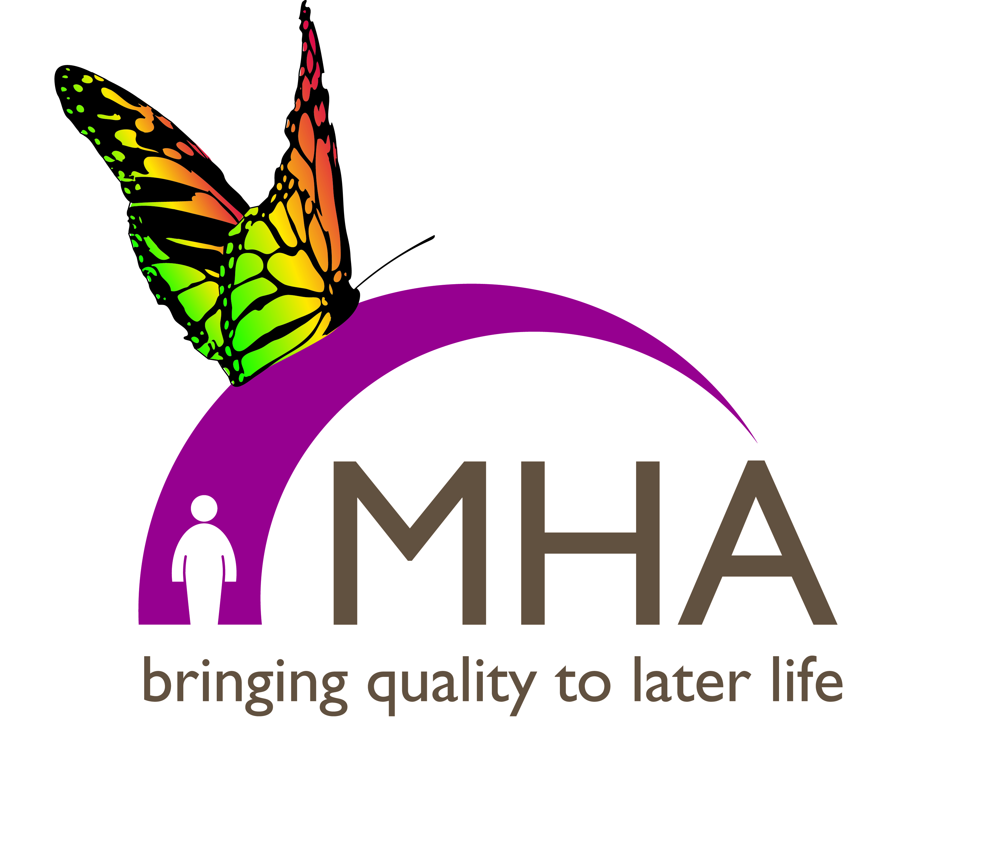

Celebrating MHA’s 75th Anniversary Year - 2018

75 years ago the MethodistConference agreed to set up MHA and the charityis continuing and improving on the care it was created for.Fast forward to 2018 and MHA now runs 90 carehomes, 72 retirement living schemes and 61 Liveat Home schemes, supporting more than 17,800older people across England, Scotland and Wales,employing 7,000 staff and enjoying the support ofover 5,500 volunteers.

On Saturday 13 October 2018 there will be a 75th anniversary Service of Thanksgiving for MHA
at 3 pm in Derby Cathedral. Please keep an eye on the MHA website for details on how to attend.

Methodist Homes Sunday – 10th June 2018
This year our theme of worship is: ‘Full of Years’and we invite church groups to celebrate Methodist HomesSunday by taking our theme and looking at ways in which we can help one another to support older members of our church and society as well as recognise and value the unique insights and perspectives of those who are in later life.
An Order of Service and other worship resources can be downloaded from our website at www.mha.org.uk/mhsor contact Lesley France on 01332 296200 or email lesley.france@mha.org.uk for printed copies.
Impact Report 2017
Our latest Impact Report shows examples of where our money comes from and where it goes. With the help from our supporters, we are delighted to report an increase in the number of Music Therapists, Chaplains and Live at Home schemes, services which are all supported by our charitable income. You can download a copy of the report from our website or contact us as above for a printed copy.

MHA’s New CEO
In February we welcomed MHA’s new CEO Sam Monaghan who began with a busy schedule of visits to MHA’s Care Homes and Schemes. At the start of his role he said “It’s important that weimprove others’ understanding andrecognition of the work MHA does.This will help to expand oursupporter base, both in termsof fundraising to increase therange of services we can offer,and in terms of influencing andshaping policy to support thosewe work with and for. Sam is a member of his local Methodist Church where he is involved in worship and youth leadership, as well as worship for people with dementia and learning disabilities.
MHA wins Prestigious Award
Congratulations went to MHA's Chaplaincy Team who recently won a 3rd Sector Charity Care award for our end of life care programme. Our approach to end of life care is encapsulated in our specially designed programme called ‘The Final Lap’ which aims to make sure all our Care Homes are places where death and dying are faced openly, positively and with support.
Thank You– we are very grateful for the support MHA receives from our friends within the Methodist Church and for sharing our mission to improve the quality of life for older people, inspired by Christian concern.

