Awakening
The Methodist Modern Art Collection in the Isle of Man

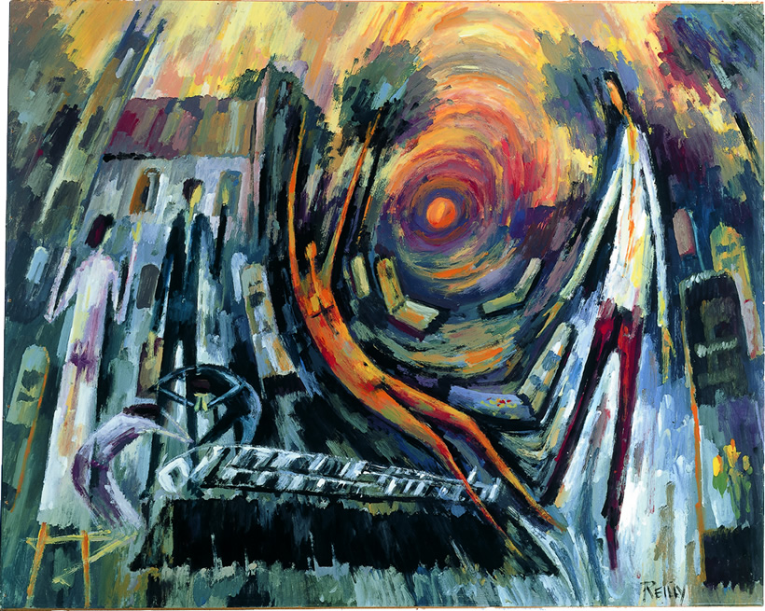


The Raising of Lazarus. 1962 John Reilly (1928-2010)
© Trustees for Methodist Church Purposes.
Weekly Bulletin Sunday May 27th.

The venues will be open as follows:

Colby Methodist Church 10.00 am – 4.00 pm daily
Sunday June 3rd 10.30 am Morning Service

Ballagarey Methodist Church
Saturday 26th May 10.30 a.m. - 3.45 p.m. ‘Come Creative Spirit’ A Quiet Day with Revs Kath Corkish and David Shirtliff. An opportunity to explore the creative work of the Holy Spirit with paintings from the Methodist Collection of Modern Art.
Please bring a packed lunch. To book your place contact David Shirtliff on 01624 621968 or david.shirtliff@manx.net
Sunday May 27th 6.30 pm Evening Service
Wednesday 30th May 10.00 am – 4.00 pm Artist in residence: Petrina Kent
Sunday June 3rd 11.00 am Morning Service

The Cathedral, Peel 9.30 am – 5.30 pm daily
Sunday May 27th 8.30 am Eucharist
10.30 am Morning Worship with Eucharist
3.30 pm Choral Evensong
Sunday June 3rd 8.30 am Eucharist
10.30 am Morning Worship with Eucharist
3.30 pm Evening Prayer

Ramsey Methodist Church 10.00 am – 4.00 pm daily
Sunday 27th May 11.00 am Morning Service

St Andrew’s URC Church 10am-4pm Thursdays, Fridays and Saturdays
Sunday May 27th 11.00 am Morning service
Sunday June 3rd 11.00 am Morning service

The Promenade Methodist Church 10.00 am – 4.00 pm daily
Saturday 26th May 3.30 – 5.30 pm Messy Church
Sunday May 27th 10.30 am Morning Service
3.00 pm – 5.00 pm Afternoon Tea in the Coffee Lounge overlooking the exhibition space
Tuesday 29th May 7.30 – 9.30 pm Alexander Brown Presents A one man show: ‘The Gospel of John’
Wednesday 30th May 7.00 – 9.00 pm How to Draw Manga Beginners Workshop with Roz Stimpson
In the Coffee Lounge overlooking the exhibition space
Adults and teens welcome (School years 7+)
Saturday 2nd June 10.00 am -12 noon Coffee Morning in lounge overlooking exhibition space
Sunday June 3rd 10. 30 am Morning Service
3.00 pm – 5.00 pm Afternoon Tea in the Coffee Lounge overlooking the exhibition space

Laxey Methodist Church
Sunday 27th May 6.30 pm. Jazz service with talk by Mary Gulland, professional artist. (Music from 6.15 pm)

Forthcoming Events

The Promenade Methodist Church
Coffee Morning in lounge overlooking the exhibition space 10.00 am -12 noon every Saturday
Artist in residence: Mary Gulland. Mondays, Tuesdays, Thursdays and Fridays.
Every Sunday: Afternoon Tea in the Coffee Lounge overlooking the exhibition space 3pm – 5pm

Ballagarey Methodist Church
Artist in residence: Petrina Kent 10.00 am – 4.00 pm Friday 8th June.

Ramsey Methodist Church
Tuesday 5th June pm, Thursday 7th June am and Friday 8th June pm Michael Starkey (Manx Artist) will be welcoming visitors and will also have some of his own work available in the downstairs foyer.
Sunday 10th June between 2.00pm and 3.30pm. Hartes Ease will be playing a programme of Renaissance music in the art space.

Other related events
St Catherine’s Church, Port Erin. Silk painting exhibition by Mary Gulland: “The Great Rescue” 9.00 am – 5.00 pm daily

Please email any items for inclusion in the bulletin for Sunday June 3rd to John Binns at jbinns39@gmail.com by 8.00 pm on Tuesday May 29th

Location of works

Ballagarey Methodist Church, St Mark’s.

St Andrew’s United Reformed Church, Douglas

Colby Methodist Church

The Cathedral, Peel

Ramsey Methodist Church

The Promenade Methodist Church

