BALDRINE HARVEST SERVICE
SUNDAY 21 OCTOBER 2018
at 3pm
BALDRINECHAPEL HALL
Revd ANDREW FISHBURNE
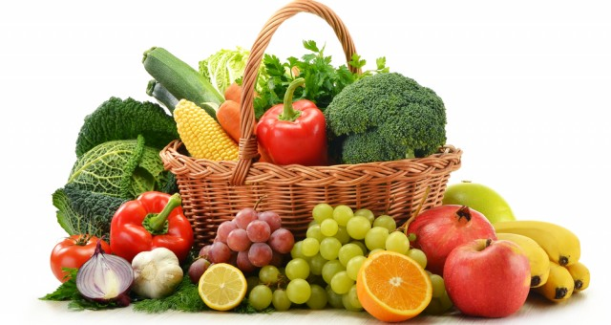
ALL WELCOME

HARVEST GIFTS TO BE DONATED TO IOM FOOD BANK

HARVEST SUPPER
MONDAY22nd OCTOBER 2017
At 7pm
Bookings for supper at £10.00
Contact Mrs J Powell 861713

Food donations
- Tinned Meat or Fish
- Tinned stew, curry, sausages, meatballs, etc.
- Chick peas, Lentils, etc.
- Breakfast Cereal and Porridge Oats
- Tinned Fruit
- Rice Pudding
- Custard – instant, tinned or long-life cartons
- Instant Mashed Potato
- Instant pot meals (needing only a kettle to prepare)
- Tea, Coffee and sugar – small packs and jars are best
- UHT Milk
- Fruit Juice
- Pasta, rice and noodles
- Pasta Sauce
- Tomatoes and other vegetables – tinned or long-life cartons
- Baked Beans
- Soup – tinned, packet
- Biscuits
- Condiments and stock cubes
Toiletries and household items
- Toilet Rolls
- Toothpaste and toothbrush
- Shampoo
- Deodorant
- Soap
- Sanitary products
- Nappies, wipes etc.
- Washing Powder

