A prayer & Action request for the Burundi Beekeeping mission
AIM: wrap Harry, Burundi & his mission in prayer!
Key features:
- An inspiration to all
- Gods strength, in us, in action
- Our legacy – the amazing things we are able to do – at any age! (subtext – what are you holding back?)

Request:
- Establish a prayer station in every of the Islands Churches!
- Include in your prayers for the period 20.02.19-10.03.19
Information:
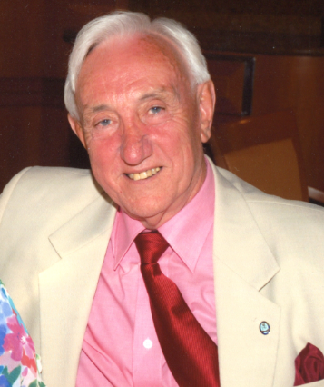
Excitingly, the postponed project is now going ahead. Harry will be departing for Burundi on the 20th of February and returning to the Island on the 11th of March 2019.

Harry Owens is the Islands own octogenarian (84 years young this year) adventurer! He is embarking on the adventure of a lifetime, which will change lives for generations to come. Harry the Island’s bee disease officer is going to train over 300 female beekeepers, as well as groups of youths in how to make beehives and the protective clothing. He has over 50 years’ experience in beekeeping and strongly feels the call to pass this information on to this country to empower the women to change their lives, to add nutrition to their diet and additional funds to pay for essential items like school and education.

The project
This is an exciting and totally unique to the Island collaboration with the IOM Beekeepers and IOM Christian Aid. Louise Whitelegg visited the Burundi Beekeeping Cooperative project in Feb 2018. The project had only started inNovember 2017, on an incredibly small scale, with very limited internal funding. Originally, the basis of the project was modelled on a Kenyan project (a previously successful IOM Christian Aid week appeal) to utilise the precious space between crops, to supplement income of subsidence farmers with bee crops. In Burundi,cooperatives of women were set up, equipment given. The next step was to train local women and youth in the art of beekeeping. However, with a shortfall in funds, peer to peer training was devised, which, unfortunately was not effective. This was the situation Louise witnessed, sufficient infrastructure but a lack of knowledge, a Manx solution was born! Harry’s trip is to train and educate the cooperatives not only ensures how to safely and efficiently manage the bees but how to make the equipment they need locally, how to utilise all aspects of the bees precious work.

By Harry imparting his gift of 50 years of education and practice, the cooperatives will be able to produce their own nutritious honey, supplementing the poor diets, with any excess to be sold at profit.

If you would like to follow Harry’s adventure, please follow Christian Aid IOM on Facebook:
https://www.facebook.com/ChristianAidIsleofMan/
Alternatively if you would like to hear or organise a talk on Harry’s return or you would like to make a donation towards the project, please contact me on 474275, or lwhitelegg@christian-aid.org or write to Christian Aid, Marlbrook, Kerrowmoar, Lezayre, IM7 2AX
Please use the prayer suggestion below (or similar) as part of your intercessions while Harry and the team are working in Burundi

Thank you:
I would like to say, a massive heartfelt thank you to every one of you for making the Bee project a reality. This year my health leaves me in a very different place, and I am reaching out to you all to help me support Harry on his mission!
In February 2018, I sat in a field with the Burundian lady beekeepers, listening to their issues and day dreaming about this trip, it is breath-taking to me that we are only weeks away from it happening! It has taken a lot of effort and hard work to get to this stage, all of which I am eternally grateful for and would not have been possible with out the help of all those who share the vision. THANK YOU to each and everyone of you for making this possible.
Every Blessing,
Louise Whitelegg
Prayer
Father, thank you for the courage of individuals, who stand up to make a change.
Thank you for those whose support makes it possible to love our global neighbours as you want us to.
We offer up to you the safekeeping of Harry Owens as he travels from the Island and around Burundi.
Please bless Harry with your strength of heart, mind and body.
May his mission to educate the Burundian women and youth in the life-giving art of beekeeping, be understood, embraced and live on through future generations.
Thank you to all who act with selfless love to make your Kingdom of Heaven on Earth possible.
Amen

