Bride Methodist Chapel

Sunday 14th October
2.30pm led by Rev.S Ingrouille
With Sunday School Children taking part
6.30 pm preacher
Mrs Brenda Kinnish
With musical items by John Kaighen

Refreshments will be served after the evening service
And dispersal of produce

Monday please note no service

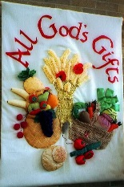

Everyone welcome

