Your invitation to

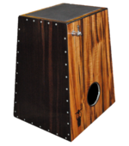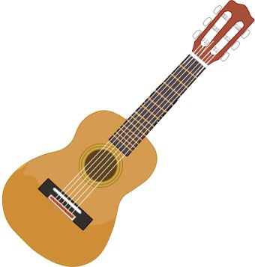
Theme: New Beginnings
Testimony Activities for adults & children Refreshments
Sulby Methodist Church Saturday 25th January 4pm

