BALDRINE HARVEST SERVICE
SUNDAY 18th OCTOBER 2020
at 3pm
BALDRINE CHAPEL HALL
With Ms Stephanie Grey
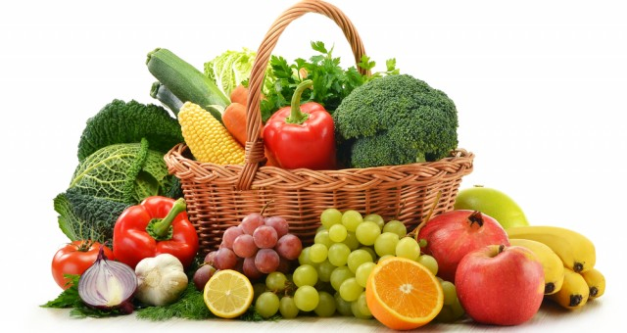
ALL WELCOME

HARVEST GIFTS TO BE DONATED TO IOM FOOD BANK
HARVEST SUPPER
MONDAY 19th OCTOBER 2020
At 7pm
Bookings for supper at £10.00
Contact Mrs J Powell 861713

