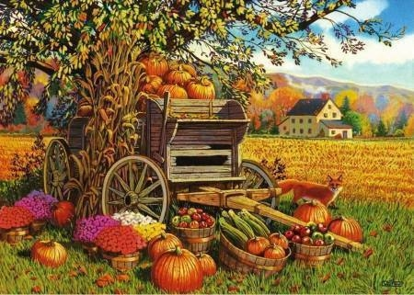

CROSBY METHODIST CHAPEL

HARVEST FESTIVAL SERVICE

SUNDAY 11th OCTOBER 2020
COMBINED WITH MAROWN PARISH CHURCH

Revd. RICHARD HOOTON
at 11.00

EVERYONE MADE VERY WELCOME

