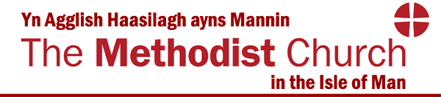

Twinned with the Methodist Church of Sierra Leone

Application for a grant from the District Advance Fund.

Please provide answers to the following questions to help us consider your application

- Please give a brief description of the object of the grant application.

- Please give the date of the Church Council at which this application was approved and the name of the person who chaired it.

- Please give details of any other funding bodies that you intend to apply to or have made application to.

- Please enclose a copy of your most recent standard form of accounts return

- Give details of any monies that will be given to this project from Church funds.

- Please state how this project/scheme has been envisioned and objectives set.

- Please give details of the total cost of your project.

- Please state the amount of grant you are requesting.
(The current maximum is £2,000.00)

- How will you monitor and evaluate the progress of the scheme in relation to the mission objectives?

- Any other information you would like to add?

