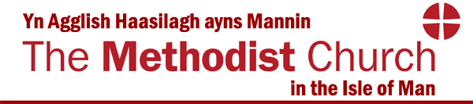

Twinned with the Methodist Church of Sierra Leone

“Creating Safer Space”
As the people of the Methodist Church we are concerned with the wholeness of each individual within God’s purpose for everyone. We seek to safeguard all members of the church community of all ages.

We are committed to:
- the care and nurture of, and respectful pastoral ministry with, all children, young people and adults
- the safeguarding and protection of all children, young people and adults when they are vulnerable
- the establishing of safe, caring communities which provide a loving environment where there is informed vigilance as to the dangers of abuse.

If you have a concern about the wellbeing of any child or vulnerable adult you should contact:

In the first instance
LOCAL CHURCH SAFEGUARDING OFFICER:
Please add details

If not available your own minister
Please add details

If not available
ECUMENICAL SAFEGUARDING ADVISOR
TONY CONNELL Tel: 07624 235970

If none of the above is available
SOCIAL SERVICES
CHILDREN AND YOUNG PEOPLE
office hours 01624 686179 out of hours 01624 631212
ADULTS
office hours 01624 686179 out of hours 01624 650000

