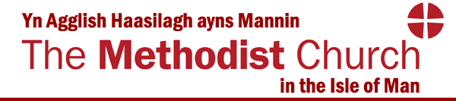
Twinned with the Methodist Church of Sierra Leone

Your application for a Circuit Grant

Name of Church:

Name of Project (If applicable):

Property Consents Reference (If appropriate):

Person to contact regarding the scheme (Give name, phone and email address):

- Please give a brief description of the project for which this grant is requested. What do you plan to do? How many people, events, or activities will this Project impact upon? (Outputs)
- Please give details of the mission policies of the Local Church/Group and indicate when the policies were adopted, and when they were most recently reviewed.

Please give details, under the appropriate headings, of how the project aims to meet the ‘Criteria for Grant Applications’

Please give details of the risks of the project that have been identified from your risk evaluation.
- What changes, benefits, learning or other effects do you plan to achieve through this Project? (Outcomes)
- If the project includes appointment of paid staff, please confirm that this has been approved by the District Lay Employment Committee, giving the date of approval and any comments made by the District Lay Employment Adviser.
- What is the total anticipated cost of the project?
- What is the commitment from the Local Church/Group? Include fund raising, use of church funds, time and skills of members.
- What is the amount of the grant being requested?
- If the grant is approved, would it be payable as a lump sum or would
it be paid in instalments to be spread over a period of years?
- If the grant is approved, when do you anticipate it needing to be paid?
- Please list below other funders who have or are going to be
approached for grants, giving details the names of the funders, the
amounts asked for/confirmed, and details of when a decision will/has been
given (please continue on a separate sheet if necessary).
Name of funder | Amount | Date of decision | Decision
- Is the project expected to continue beyond the period for which funding is being applied in this application?

Yes/ No
If yes, please answer question 12 below.

- Is the project expected to become self-funding within the foreseeable future?

Yes/No
If yes, please give details of how this will be achieved
If no, please give details of any current plans for project funding after any grant received as a result of this application has been used up.

Please enclose with your application:
- The budget of income and expenditure for the project;
- The most recent audited financial accounts of the Church/Group; and
- Job descriptions for any staff to be employed as part of the scheme or project.

Please note: All applications must be approved by the Circuit Meeting as well as by any relevant Church Council/Group Trustees.

When completed the form should be sent to the District/Circuit Office via email to administrator@methodist.org.im or by post to: Methodist Church Isle of Man District Office, Trinity Methodist Church, Rosemount, Douglas, IM1 3EY.

I confirm that the above application has been approved by the Church Council/Group Trustees on: ..………………………………………………. (Date)

Signed: ...……………………………………… (Chair)

Date: ..………………………………………….

